(Approx. 937 words)

Time to Replace Your Computer? Do this first.
By Phil Sorrentino, Secretary, and APCUG Rep
Sun City Center Computer Club, FL
https://www.scccomputerclub.org/
philsorr ** yahoo.com
To most of us, replacing our computer is a double-edged sword. There is the joy of expecting to take advantage of newer, faster hardware and software, and then there's the challenge of the unknown, new features. This is especially true now because we have been using Windows 10 for a long time and our next computer will undoubtedly have Windows 11. Windows 11 was released in October 2021. All computers from typical manufacturers like Dell, HP, ASUS, Microsoft, Toshiba, Lenovo, etc., come with Windows 11. Windows 11 does have some new features, but most Windows 10 users should feel comfortable with Windows 11 once they find out where their favorite features are. They're all there, but the path to get to them is not always clear. Before you think about how to use the new computer, there is one last thing you should do with your old computer. And that is to ensure no personal information is on the old computer. You may be giving the computer to someone, or you may be donating the computer to a service that refurbishes computers for re-distribution, or you might take it to an e-waste facility. You don't want your private information to go to the new user. (As for donated computers, I can confidently say that all the Computer User Groups I have been associated with always wiped the hard drives before anything else was done. Hard drives are often not even useable, so they are removed and destroyed, usually with a hammer or drill.)
Just a brief technical discussion. By now, most computer users know that deleting a file does not actually remove the file from the computer, and with some basic software, the file can be read (as long as another file has not been written over it). The first byte of the file indicates whether it is deleted or not. This may have been done to make it very easy for the Operating System to delete files, so it doesn't take too much time, especially if you are trying to delete hundreds of files at a time. But this leaves the file on the drive intact, except for the fact that the first byte indicates it has been deleted. When the file is deleted, all of the data space is returned to the Operating System so it can use the space again when it needs space for a new file. Depending on what else is happening, the deleted file may be written over in the next few seconds, but it might remain intact or partially intact for a long time. Of course, if it contains personal information, that information is at risk.
In the past, it was more difficult to ensure you removed all your personal information because the functionality wasn't part of the Operating System. Instead, you had to use a separate software program developed specifically for writing useless data into all of the space originally occupied by data files. There are many of those programs available, one of which is called DBAN. But today, Windows 10 makes the job very easy because that functionality can be found in Settings' "Update and Security" section. First, choose the "Recovery" option, then "Get Started," and finally, select "Reset this PC." At that point, you will be presented with "Keep my files" and "Remove everything." "Keep my Files" Removes apps and settings but keeps your personal files; you don’t want this choice. "Remove everything" Removes all your personal files, apps, and settings, which is what you want. Choosing "Remove everything" will write zeros into all of the space used by your files. Once zeros are written into a file's data space, that file will not be able to provide any indication of the original file contents. (The only slightly possible exception may be highly specialized hardware and software probably only owned by hard drive manufacturers and executed only by some government agency.) So, for all intents and purposes, the data is gone. (Remember that only the C: drive was wiped clean of your personal data. If you have a second drive, as might be the case with a desktop with personal data, the data is still on the second drive.) As a bonus, Windows 10 will be re-installed. The computer should be operating just like it did when you originally got it, but without any of the apps you installed and, of course, without your personal information.
If, for some reason, you are not comfortable using Windows 10's "Reset this PC," there is always software like DBAN available. DBAN is short for Darik's Boot And Nuke. DBAN is Free Open-Source Data Wiping Software for Personal Use, as it says on its website, dban.org. As you can see from the website, DBAN has many features and options, probably more than the average user will need. You can also get DBAN from filehippo.com, a reasonably safe place to download software. DBAN works well, but it comes with a warning, as shown below, and a disclaimer that "the authors are not liable for any damages arising from the use of this software," which might frighten some potential users."
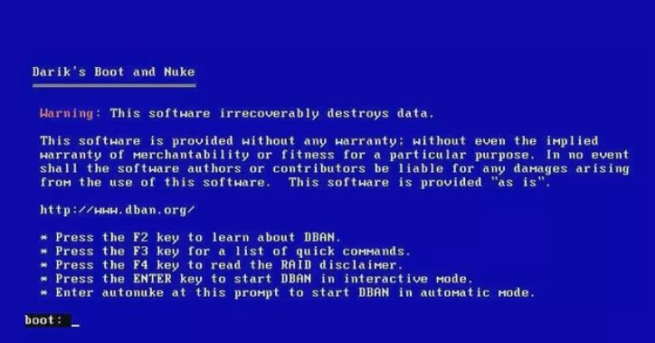
DBAN's Warning
"DBAN has been designed for the home user, and although it is good at what it does, the interface is a little clunky" is a quote from the filehippo.com description, so unless you are a technically inclined user or very adventurous, this may not be for you. Use the Windows 10 "Reset this PC" functionality in that case.

